*Florida International University*

*School of Computing and Information Sciences*

CIS 4911 - Senior Capstone Project

Feature Document

User Story #1193

# Extend Lock and Unlock Functionality for semester locks

# 

**Team Member:**

Joseph Gonzalez

**Product Owner(s)**:

Masoud Sadjadi

**Mentor(s)**:

Mohsen Taheri

**Instructor**: Masoud Sadjadi

# **User Story - Extending Lock Services to semester locks**

* As a user, I would like to lock an entire semester, so that all the projects in that semester are also locked, and so projects cannot be proposed for that semester

## **Use Case**

**Use Case ID:** (VIP-1193)

**Details:** Extending Lock Services to a Semester Lock

**Actor:** Users

**Pre-Condition:**

* Projects have been created and assigned a semester
* Terms have been created in the terms collection

**Description:**

1. Use Case Begins when a Pi/CoPI navigates to the admin panel (vip.fiu.edu/#/admin-panel)
2. Pi/CoPI navigates to the “Lock/Unlock Semester” Panel
3. In the drop down menu labeled “Term” Select a semester
4. In the second drop down menu labeled “change Semester's status to” the desired status
5. Once both menus have options filled out, press the button labeled “Change”
6. A pop up message will appear indicating a change has been made

**Post-Conditions:**

1. The term’s status has been updated
2. Any projects from that term are also locked

**Alternative Course of Action**

N/A

**Exceptions:**

N/A

**Related Use Cases:**

Lock/Unlock a Project

**Decision Support:**

**Frequency:** Low: This occurs only a few times a semester.

**Criticality:** High: This affects which projects are available to users and which semesters projects can be proposed for

**Risk:** High.

**Constraints:**

1. **Usability:** 
   1. Requires no coding experience
2. **Reliability:** 
   1. Availability – At Users will
3. **Performance:** 
   1. Completes modifications to the database within 5 seconds, which is deemed acceptable
4. **Supportability:**
   1. All modern web browsers should be supported.

**Modification History:**

**Owner:** Joseph Gonzalez

**Initiation date:** 10/15/2016

**Date last modified:** 11/1/2016

**Use Case Diagram**

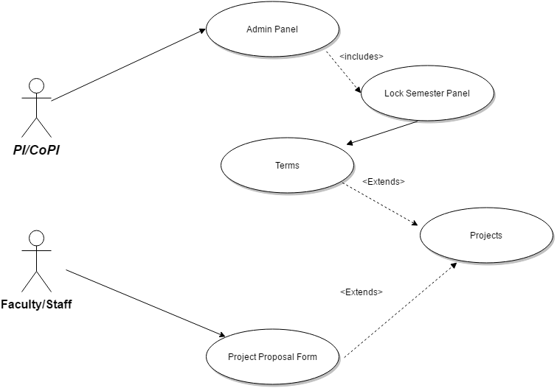

**Sequence Diagram**

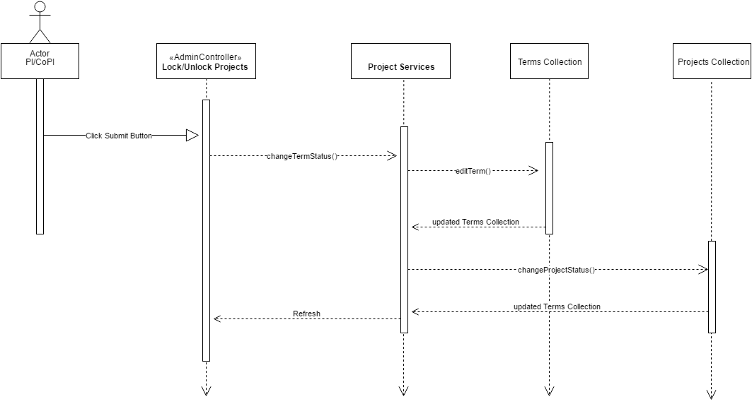

**Class Diagram**

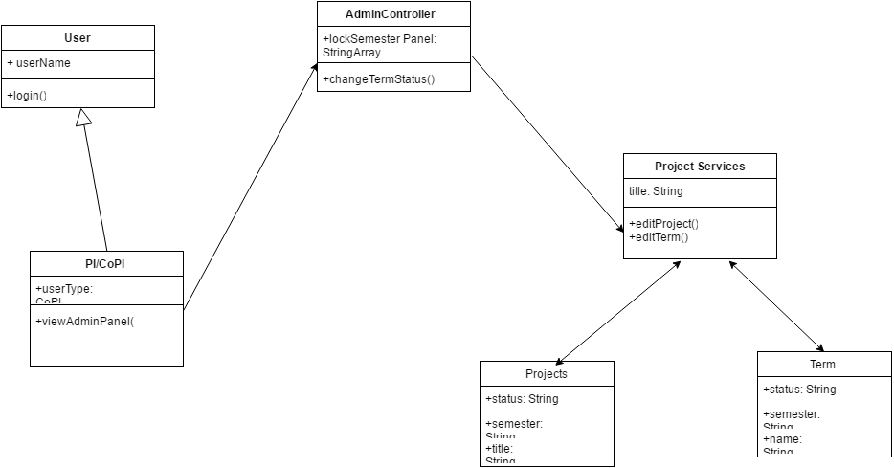

**Unit & Integration Tests:**

**Test Case 1 (Sunny Day)**

**ID: VIP-SD-1193-01**

**Purpose**

* Test that the lock is changing the status of the term collection

**Precondition**

* The Lock/Unlock Semester panel has been filled out

**Input**

* The status of the term has been changed

**Expected Result**

* The status of the term in the terms collection now matches the option selected

**Actual Result**

* Same as expected.

**Test Case 2 (Sunny Day)**

**ID: VIP-SD-1193-02**

**Purpose**

* Confirm that a Project cannot be proposed in a locked semester

**Precondition**

* A term has been locked
* The same term is selected in the “Semester” section of the “Project Proposal Form”

**Input**

* The user attempts to submit the project under the locked term

**Expected Result**

* An error message indicates that the semester is locked and the project cannot be proposed for that project

**Actual Result**

* Same as expected

**Test Case 3 (Sunny Day)**

**ID: VIP-SD-1193-03**

**Purpose**

* Test that projects from a now locked semester are also locked

**Precondition**

* The projects term has been locked

**Input**

* A user attempts to join a project from a locked term

**Expected Result**

* They are given an error message preventing them from joining the project

**Actual Result**

* Same as expected.

**User Guide**

Once logged into the site, Navigate to the login panel

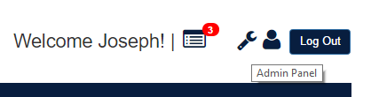

From there, scroll down to the “Lock/Unlock Semester” Panel

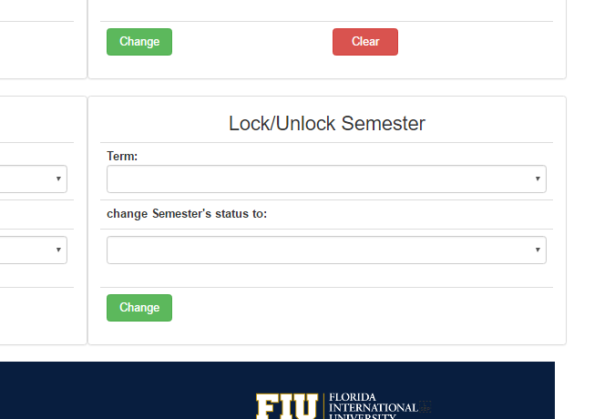

Select an option in the “Term” menu, and an option from the “change Semester’s status to” menu. Then click the “Change” button underneath. You have now locked a semester.To test if the lock is working first, try to propose a new project for that locked Semester. In this example we’ve Locked “Summer 2017”.

Once you attempt to propose the project during the now locked Semester, the following message should appear after you press “Submit”

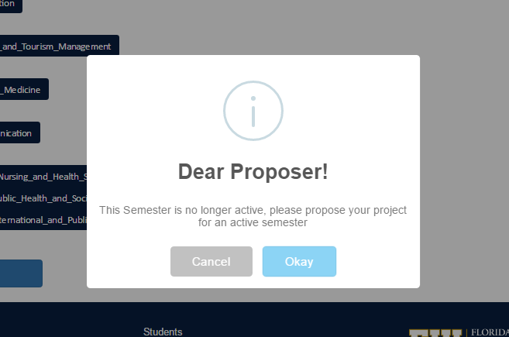

Projects that belonged to a newly locked Semester will also now be locked, you can also confirm the lock by checking any project that should now be locked (refer to Use Story #1101 for more details).